Name and Section:

Organismal – Prof Goffe

Symbiotic Relationships/Species Interactions – Lab 13

Introduction: Individual organisms not only interact with their abiotic environment but with individuals from other species on a regular basis. One type of species interaction is symbiosis. Here, two individuals of two different species live together. Sometimes this relationship can be beneficial to one and not the other (parasitism), beneficial to both (mutualism) or beneficial to one and have no impact or influence on the other species involved (commensalism). In this activity, you will choose organisms from the Savannah food web, generate symbiotic relationships and then model these pairings.

Part I: Materials and Resources
- Review Lab 13 (p116) in your text book.
- Types of Symbiosis:
http://education.nationalgeographic.com/education/activity/ecological-relationships/?ar_a=1

Part II: Video Notes

Part III: Sample African Savannah Food Web
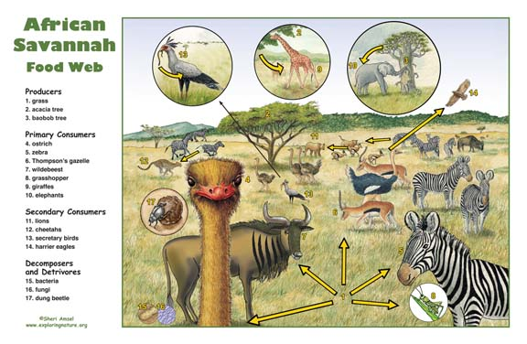

Part IV: Organism Sensory Chart

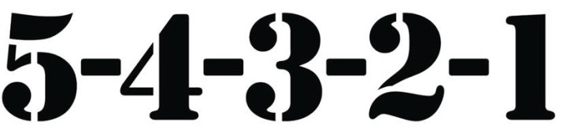
(Superior ---------------- Very Limited)

Sense | Ostrich | Zebra | Gazelle | Wildebeest | Giraffe | Lion | Hyena
Sight | 5 | 1 | 3 | 3 | 5 | 5 | 5
Hearing | 1 | 5 | 5 | 5 | 3 | 5 | 5
Smell | 1 | 5 | 5 | 5 | 3 | 5 | 5

→ Review the data table above. You will notice that the senses are ranked from superior to very limited. Considering that you are about to pair up two primary consumers into a mutualistic relationship, specifically explain how might you use the table above to quantitatively justify your pairing?

→ Prey animals tend to have monocular vision (eyes on the side of the head that view the world separately and do not provide quality 3D vision). Predators tend to have binocular vision where both fields of vision do overlap and provide 3D vision. The Organism Sensory Chart states that zebras have poor sense of sight. Considering the placement of the eyes on zebras, how can you explain their very limited vision?

Part V: Competition

1. Define Competition:

2. Which secondary consumers from the food web are competitors on the Savannah?

3. Which primary consumers from the food web do these predators both prey on?

Competition Procedures
- Obtain a coin.
- Determine which side of the coin will represent the lion and cheetah populations.
Heads = ________________ Tails = _______________
3. The side the coin lands on represents a successful kill from that predator population. When one
predator population makes a kill, their population increases by one the next time interval. In contrast,
the other predator population goes down one the next day.
4. Flip the coin 30 times representing 30 time intervals (each interval represents 5 days).
5. Record the changes in predator population in Table 1.

→ Why not just collect data for 30 days and avoid using intervals of time?

_______________________________________________________________________________________
_______________________________________________________________________________________
_______________________________________________________________________________________

Table 1 - Competition
Time Interval | Lion  Population | Hyena  Population | Time Interval | Lion  Population | Hyena  Population
0 | 15 | 15 | 15
1 |  |  | 16
2 |  |  | 17
3 |  |  | 18
4 |  |  | 19
5 |  |  | 20
6 |  |  | 21
7 |  |  | 22
8 |  |  | 23
9 |  |  | 24
10 |  |  | 25
11 |  |  | 26
12 |  |  | 27
13 |  |  | 28
14 |  |  | 29

Checkpoint: Now that you have the experimental data recorded in Table 1, review the two graphic
organizers below and choose the most appropriate one to further illustrate your data.

Option 1- Pie Graph



Option 2 - Line Graph

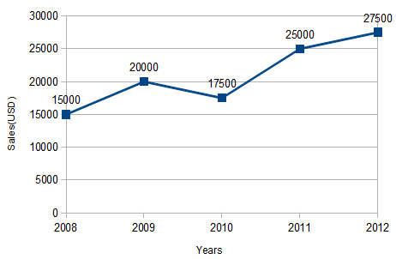

Part VI: Competition Questions

1. Did the lions or hyenas prove to be more successful?

2. Calculate the rate of hunting success for both the lions and hyenas.
Lions →

Hyenas →

3. Lions and hyenas have different hunting strategies. Explain why you can or cannot apply these
strategies as factors influencing the data.

Part VII: Mutualism
- In this section of the lab you will model mutualism and determine if organisms that engage in this symbiotic relationship both benefit. Review the Savannah food web again. Which two primary consumers do you hypothesize would pair up forming a mutualistic relationship?

If…..

Then…

Because...

Part VIII: Mutualism Procedure
- In order to address the involvement of the second primary consumer making the relationship mutualistic, a second coin flip is required.
- First coin flip identifies the attacking predator.
- Second coin flip determines if attack is successful.
3. If two consecutive coins flips result, then….. (you provide the remaining procedures)
4.

5.

Table 2 - Mutualism
Time Interval | Lion  Population | Hyena  Population | Time Interval | Lion  Population | Hyena  Population
0 | 15 | 15 | 15
1 |  |  | 16
2 |  |  | 17
3 |  |  | 18
4 |  |  | 19
5 |  |  | 20
6 |  |  | 21
7 |  |  | 22
8 |  |  | 23
9 |  |  | 24
10 |  |  | 25
11 |  |  | 26
12 |  |  | 27
13 |  |  | 28
14 |  |  | 29
Part IX: Mutualism Questions

1. Did the lions or hyenas prove to be more successful?

2. Calculate the rate of hunting success for both the lions and hyenas.
Lions →

Hyenas →

3. Referring to your data, explain why the rates of hunting success changed now that the primary
consumers are engaged in a mutualistic relationship.

4. Consider the organisms you chose to form a mutualistic relationship. Explain why you would or would
not expect them to remain in a mutualistic relationship…. at night rather than during the day.

